**Milestone 3 – Populating Database**

Aaron Galicia, Levi Guerengomba, Kyungchan Im

Grand Canyon University

Course number: CST - 217

Instructor: Nasser Tadayon

Due Date: Feb 22, 2023

[ Contribution ]

Aaron : Populating and Data collection for entities [Team, Player, Statistic]

Levi :Populating and Data collection for entities [Fan, Ticket, Matches]

Kyungchan Im: Populating and Data collection for entities [ League, Statistics ]

Revising and Creating a documentation for Milestone 3.

**Milestone 3 – Populating Database**

**[ Improved ERD Screenshot ]**

**[ Selecting Table Queries ]**

**Table League**

**Table Team**

**Table Coach**

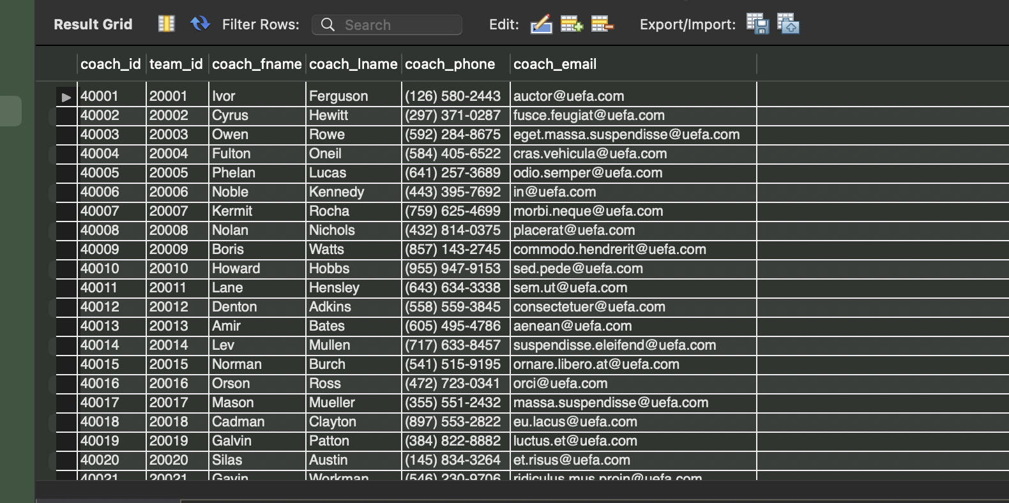

**Table Fan**

**Table Matches**

**Table Ticket**

**Table Statistic  
**